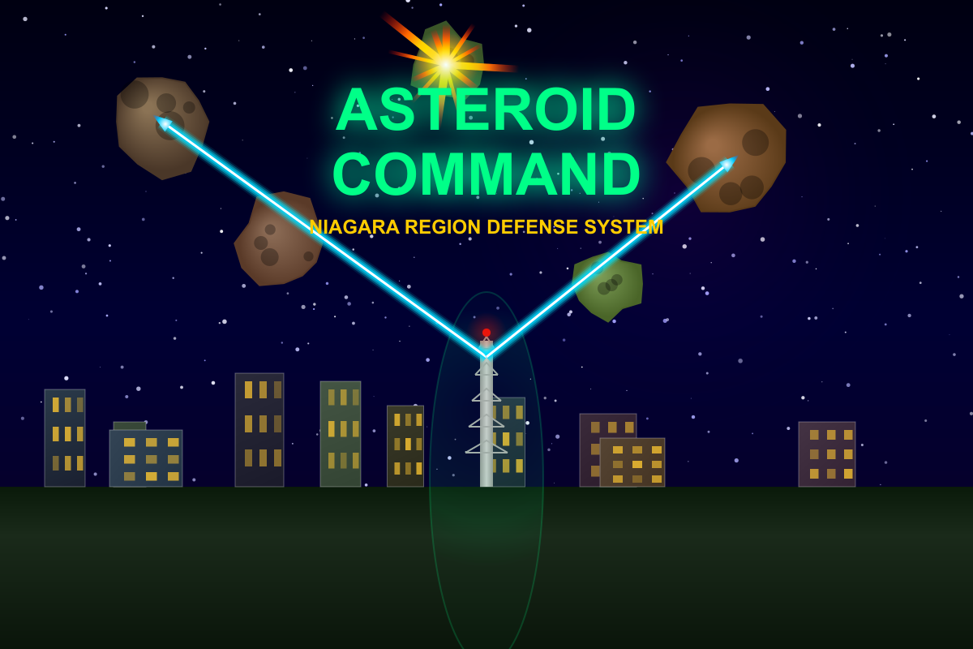

ASTEROID COMMAND
GAME PLAY MANUAL
Niagara Region Defense System
PowerLine Challenge Series

FOR 1 PLAYER

KEYBOARD REQUIRED

THE GAME
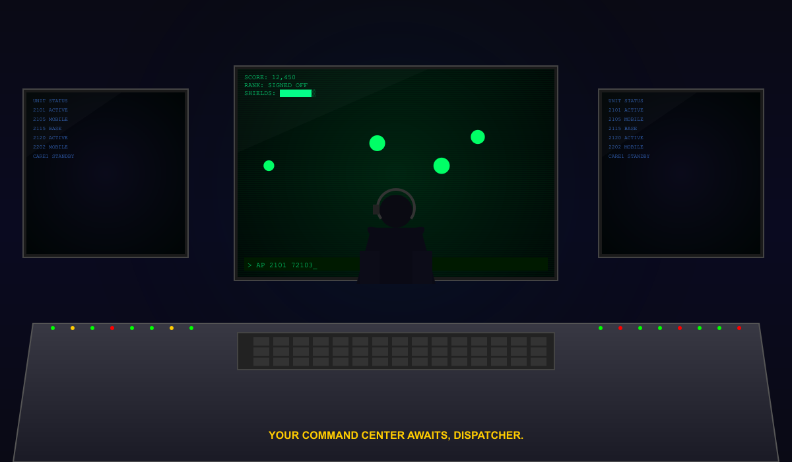
The year is 2026. Massive asteroids are hurtling toward the Niagara Region, drawn by the electromagnetic signature of the power grid. They target the landmarks that keep the region running: the hydroelectric dam, the Skylon observation tower, the Welland Canal, and the Robin Hood Flour Mill.
You are a dispatcher. Your weapon is your keyboard. Each asteroid carries an encoded radio transmission. Type the correct PowerLine command before impact to lock on and fire. Type accurately. Type clean. Earn your rank.
DISPATCHER’S NOTE: This game teaches real PowerLine CAD commands used by Niagara Region EMS dispatchers. Every unit number, base code, and radio phrase is drawn from actual operational data.

CONTROLS
KEY | ACTION
Type + Enter | Fire laser at matching asteroid
Enter (empty) | MISFIRE! Costs shield HP, resets streak
Backspace | Correct a typo (but you’ll pay for it…)
Escape | Pause / Resume the mission

GAME PLAY
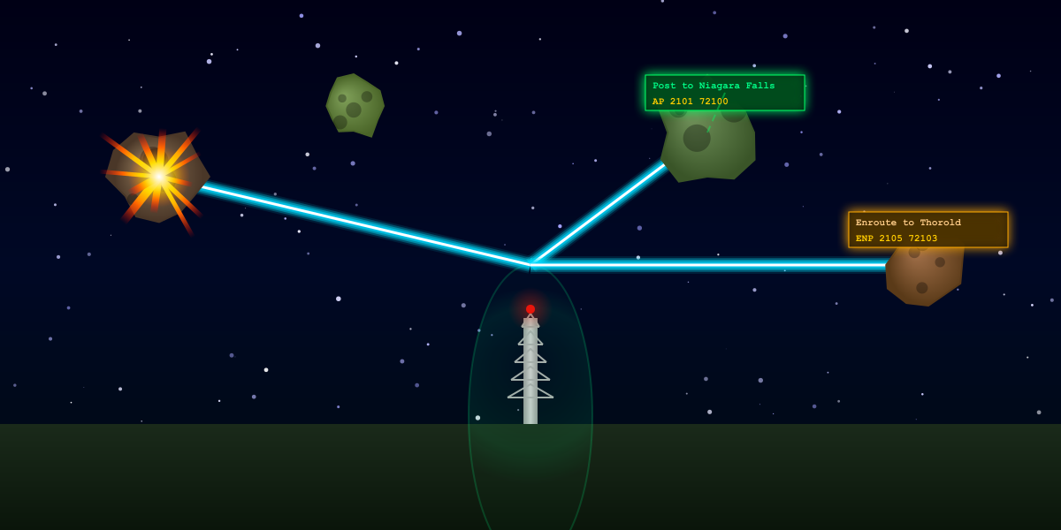
HOW TO PLAY
Asteroids appear at the top of the screen and fall toward one of the four defense zones or the Command Tower. Each asteroid carries a challenge box connected by an energy tether beam.
The challenge box shows a plain-English instruction and the PowerLine command you must type. The unit number is displayed on the asteroid itself.
Type the command exactly and press Enter. If it matches any active asteroid, your tower fires a precision laser to intercept it. Points are awarded.
MISFIRE
Type a wrong command (or press Enter with nothing typed) and your tower fires a wild shot that ricochets off your own shield dome. You lose 1 shield point. Your streak resets to zero.
ASTEROID IMPACT
If an asteroid reaches its target unchecked, the structure takes catastrophic damage.
If all four defense zones are destroyed, the region falls. GAME OVER.

COMBAT TIP: Pressing Enter with an empty command box is a MISFIRE — it damages your shields and resets your streak. Always type the full command before firing! In Holodeck mode, empty Enter auto-targets the oldest asteroid.

THE DEFENSE GRID
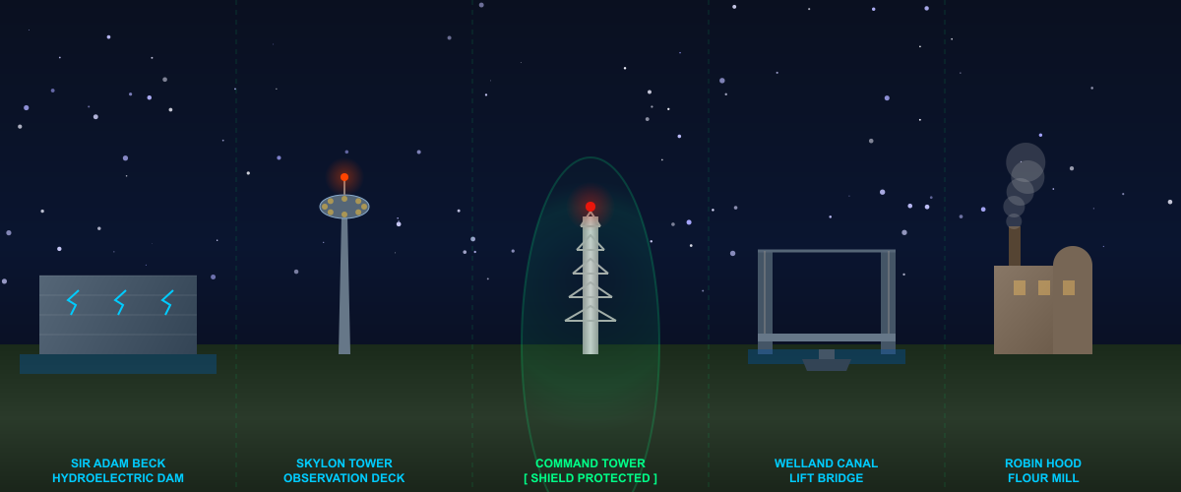
The Niagara Region Defense Grid consists of four defense zones and the Command Tower. Each is a real Niagara Region landmark reimagined as a defense installation.
ZONE | LANDMARK
ZONE 1 | Sir Adam Beck Hydroelectric Dam — powers the region from the northern edge
ZONE 2 | Skylon Tower — the iconic Niagara Falls observation tower above the gorge
TOWER | Command Tower (YOU ARE HERE) — your base. Only structure with a shield dome
ZONE 4 | Welland Canal Lift Bridge — a working bridge with freighter traffic below
ZONE 5 | Robin Hood Flour Mill — the historic Port Colborne mill and smokestacks

IMPORTANT: The Command Tower cannot be permanently destroyed — a NanoMedic repair unit will rebuild it. But while repairs are underway, you CANNOT fire. Protect your tower at all costs.

SHIELD SYSTEMS
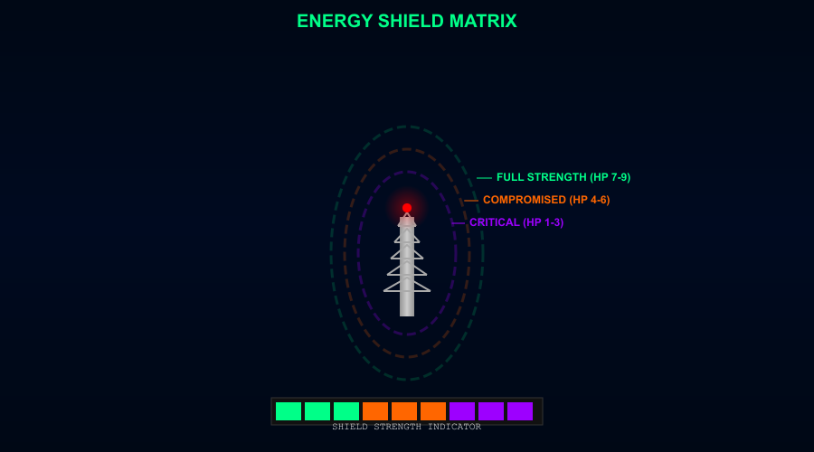
Your Command Tower is protected by a three-layer energy shield dome. Total: 9 HP. Misfires cost 1 HP. Direct asteroid impacts cost 4 HP.
HP | STATUS | VISUAL
7–9 | FULL STRENGTH | Shield glows green. Maximum protection.
4–6 | COMPROMISED | Shield turns orange. Cracks appear.
1–3 | CRITICAL | Shield turns purple. One more hit and it’s gone.
0 | SHIELDS DOWN | Tower exposed! Next impact destroys it.

NANOMEDIC REPAIR UNIT
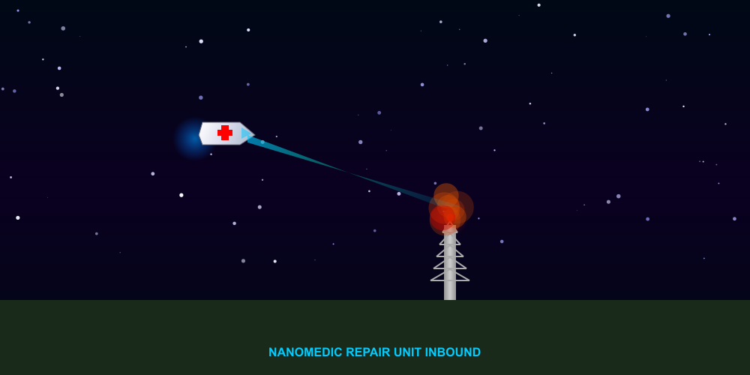
When the Command Tower is destroyed, a NanoMedic repair unit — a specialized space ambulance — is automatically dispatched to rebuild it.
The NanoMedic flies in, evading asteroids, then connects a healing beam to your tower. Each successive repair takes longer to dispatch and complete. While repairs are underway, you CANNOT fire your laser.
WARNING: The longer you survive, the longer each repair takes. Don’t let it come to this.

SCORING
Points scale with your career rank. Higher ranks earn more per hit but suffer devastating penalties for mistakes. This is high-risk, high-reward.
BONUSES
BONUS | HOW TO EARN
Perfect Shot | Type the command with zero backspaces. +25% of base hit value.
Early Intercept | Destroy the asteroid in the upper 25% of the screen. +50% of base.
Speed Demon | Type fast enough to trigger the speed bonus. +15% of base.
Kill Streak | Consecutive hits build a multiplier: 3x=1.1, 5x=1.2, up to 25x=1.75.
Perfect Streak | Chain zero-backspace hits for flat bonuses: 5x=+75, 25x=+1,000 pts.

PENALTIES
Misfire: −50 pts (flat, all ranks). Zone Impact: −50 (Trainee) to −750 (Veteran). Backspaces cost 10–20% of base hit, or flat −30/−50 at 5+ corrections.

CAREER RANKS
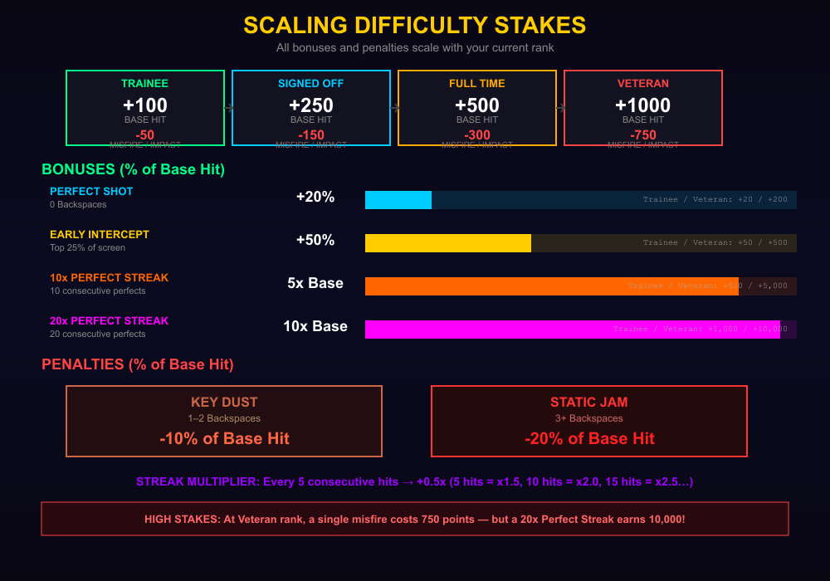
As your score climbs, you ascend through eight ranks. Each promotion increases difficulty AND scoring stakes. Your rank can also DROP if penalties push you below the threshold.
RANK | POINTS | SPEED | SPAWN | HIT | PENALTY
TRAINEE | 0 | 0.6–0.8x | 5–6.5s | +100 | −50
MENTORING | 2,001 | 0.8–1.0x | 4.5–5.5s | +100 | −50
SIGNED OFF | 5,001 | 1.0–1.2x | 4–5s | +250 | −150
OUT OF PROB | 10,001 | 1.2–1.4x | 3.5–4s | +250 | −150
2 YEARS IN | 20,001 | 1.5–1.8x | 3–3.5s | +500 | −300
FULL TIME | 35,001 | 1.8–2.2x | 2.5–3s | +500 | −300
VETERAN | 55,001 | 2.5–3.0x | 1.5–2s | +1,000 | −750
O.A.S | 80,001 | 3.0–4.0x | 0.8–1.2s | +1,000 | −750

O.A.S: Speed hits 4.0x. Spawns are sub-second. Up to 25 asteroids on screen simultaneously. This is the endgame.

ASTEROID COMMAND
A PowerLine Challenge Cartridge
The Niagara Region is counting on you, Dispatcher.
Type clean. Type fast. Save the region.
© 2026 PowerLine Challenge

